Practical Exercise on AJAX

Introduction

The BCH Ajax Plug-In is a lightweight JavaScript application based on Ajax technology that can be easily integrated to any website to allow dynamic display of information from the BCH Central Portal.

The use of the BCH Ajax Plug-In does not require any specific IT knowledge. The Plug-In works on all server platforms and does not require any software installation. All required files are located on the BCH Central Portal and maintained by the Secretariat.

The BCH Ajax Plug-In is a client side application. The connection to the BCH Central Portal is made directly by the client (end-user).

Integration

The BCH Ajax Plug-In has been designed to make its integration to any website as simple as possible.

The BCH Ajax Plug-In can be integrated to any webpage by simply adding the following lines of HTML.

<script type="text/javascript" charset="utf-8"
src="http://bch.biodiv.org/centralportal/ui/offsite/bch-offsite.js"></script>
<script type="text/javascript" charset="utf-8" >
GenerateRecords("focalPoint", "ca", "en");</script>

Here is a very basic HTML page integrating the BCH Ajax Plug-In.

<html>
<body>

<h1>National Focal Points</h1>

<script type="text/javascript" charset="utf-8"
src="http://bch.biodiv.org/centralportal/ui/offsite/bch-offsite.js"></script>
<script type="text/javascript" charset="utf-8" >
GenerateRecords("focalPoint", "ca", "en");</script>

</body
</html>

Customization

The BCH Ajax Plug-In can be easily customized to show any specific type of BCH national information for any country. Support for languages is currently under development.

The BCH Ajax Plug-In can be customized by simply changing the parameters of the GenerateRecords method defined below.

function GenerateRecords(documentType, country, language);

documentType

The parameter specifies what type of BCH national information to display. The valid values are the following:
Type of information to display | Value
National Focal Point | focalPoint
Competent National Authority | authority
National Database | nationalDatabase
Law, Regulation or Guideline | law
Agreement or Arrangement | agreement
Decision on LMO | decisionUnderAIA
Decision on LMO-FFP | decisionUnderA11
Other Decision | decision
Biosafety Expert | biosafetyExpert
Report on Assignment | biosafetyExpertAssignmentReport
Capacity Building Opportunity | capacityBuildingOpportunity
Capacity Building Project | capacityBuildingProject
Capacity Building Need or Priority | countryNeedsAndPriorities
Risk Assessment | riskAssessment

country

The parameter specifies what country for which the information is displayed. The BCH Ajax Plug-In uses 2-letter ISO 3166 country codes.

The official list can be found at:
http://www.iso.ch/iso/en/prods-services/iso3166ma/02iso-3166-code-lists/list-en1.html

language

Some language codes  Language to display | Value
English | en
Russian | ru
Spanish | es
Exercise

Open the AJAX Folder that is on your desktops.
Double-click on the “my_first_ajax” file.
On top you will see a warning message. Click on it and choose “Allow Blocked Content…”.

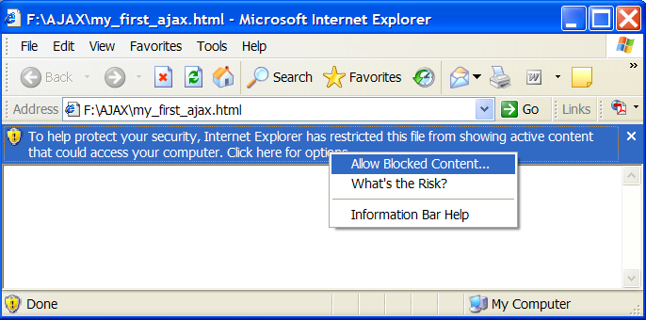

You should see the following window. It shows the list all National Focal Points for Canada in French.

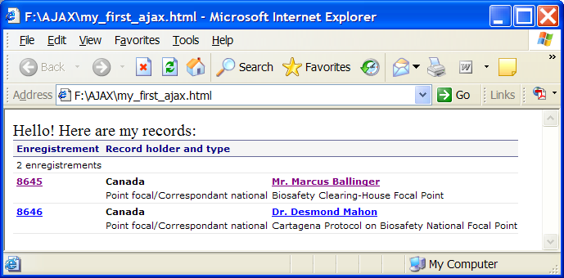

Go back to your AJAX folder and right click on the “my_first_ajax” file and go to “Open With” and choose “Notepad”.

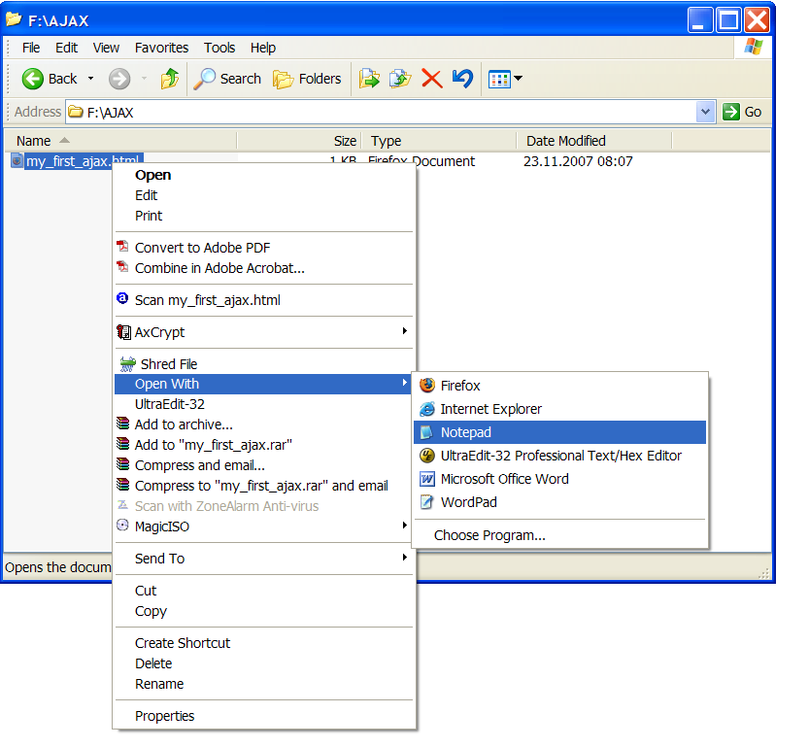

You should see the following window:

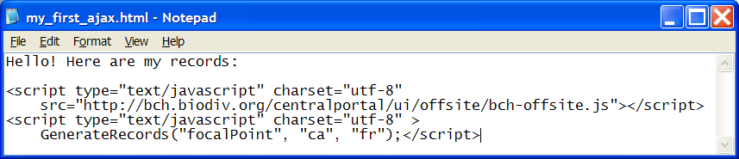

Do the following quick exercises:
1. Display the list of all Laws, Regulations and Guidelines for Brazil in Spanish.
2. Display the list of all Risk Assessments for New Zealand.

Answer key

Exercise 1:

<script type="text/javascript" charset="utf-8"
src="http://bch.biodiv.org/centralportal/ui/offsite/bch-offsite.js"></script>
<script type="text/javascript" charset="utf-8" >
GenerateRecords("law", "br", "es");</script>

Exercise 2:

<script type="text/javascript" charset="utf-8"
src="http://bch.biodiv.org/centralportal/ui/offsite/bch-offsite.js"></script>
<script type="text/javascript" charset="utf-8" >
GenerateRecords("riskAssessment", "nz", "en");</script>

